1. Bot will enter the URL - <https://my.newport.gov.uk/myNewport.aspx>

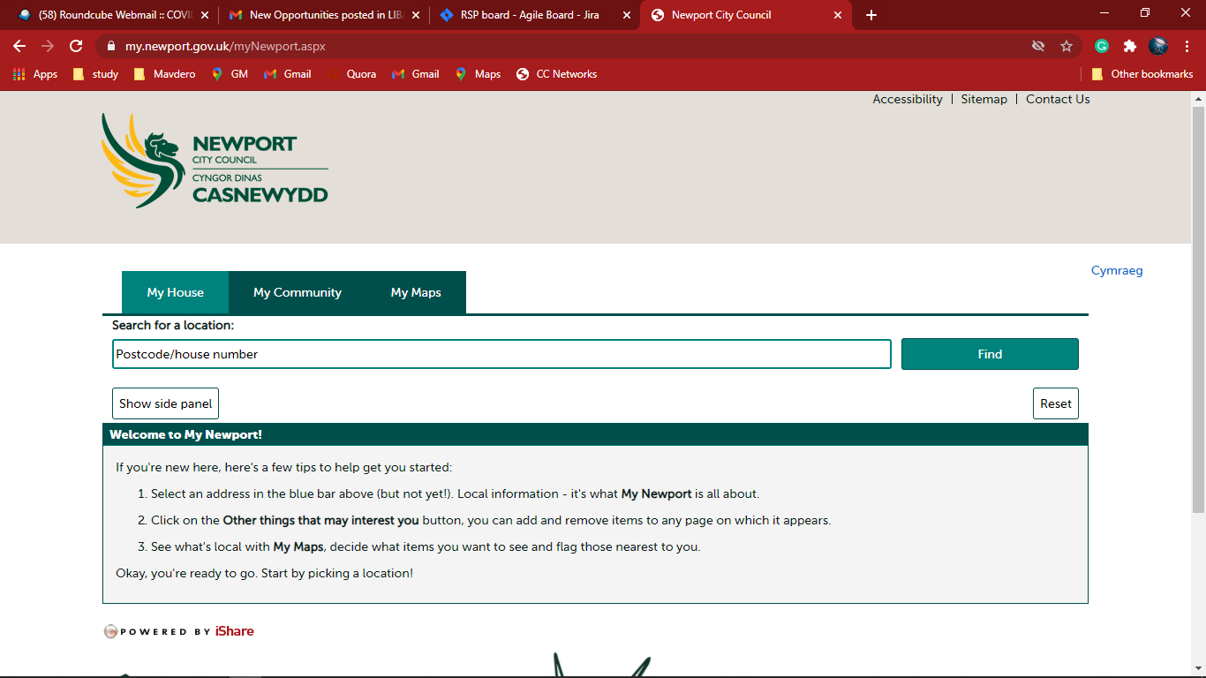

1. Bot will click and go to the My Maps

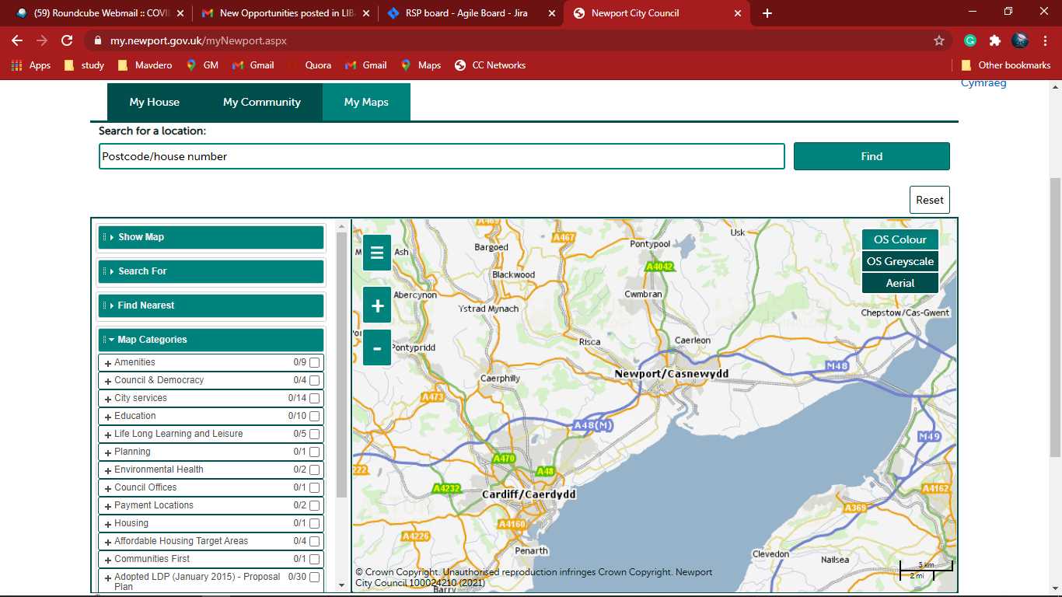

1. Bot will enter the Postal Code
   1. Bot will click **Find**
   2. Bot will select the property address

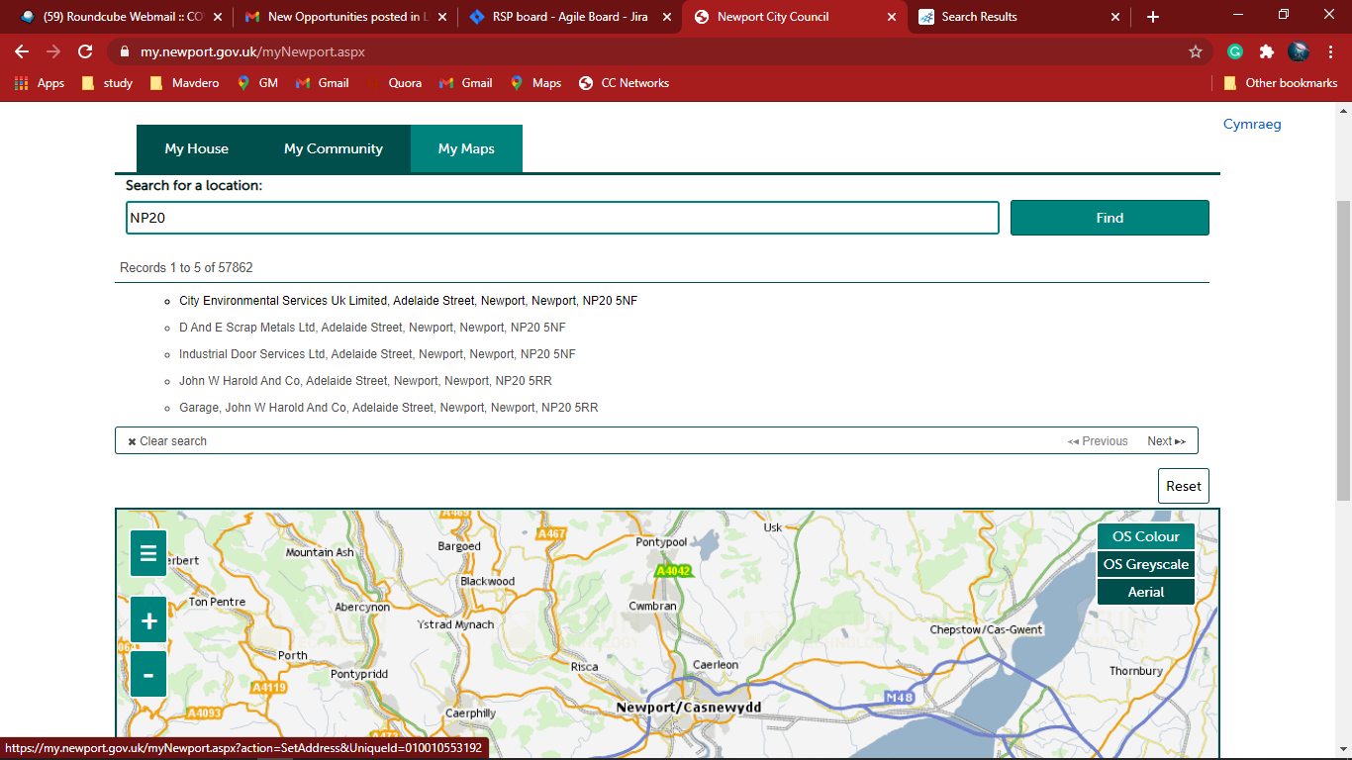

1. Bot will Select the “Map Categories” on the side bar

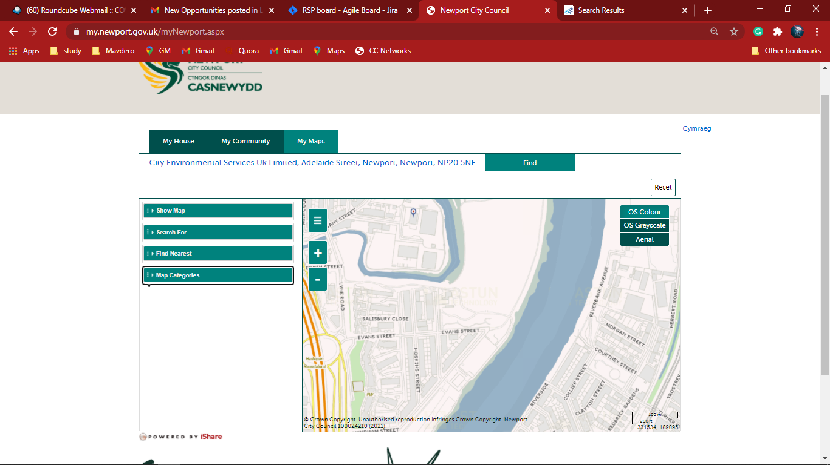

1. Bot will select the “Planning” – Under Map categories on the side bar

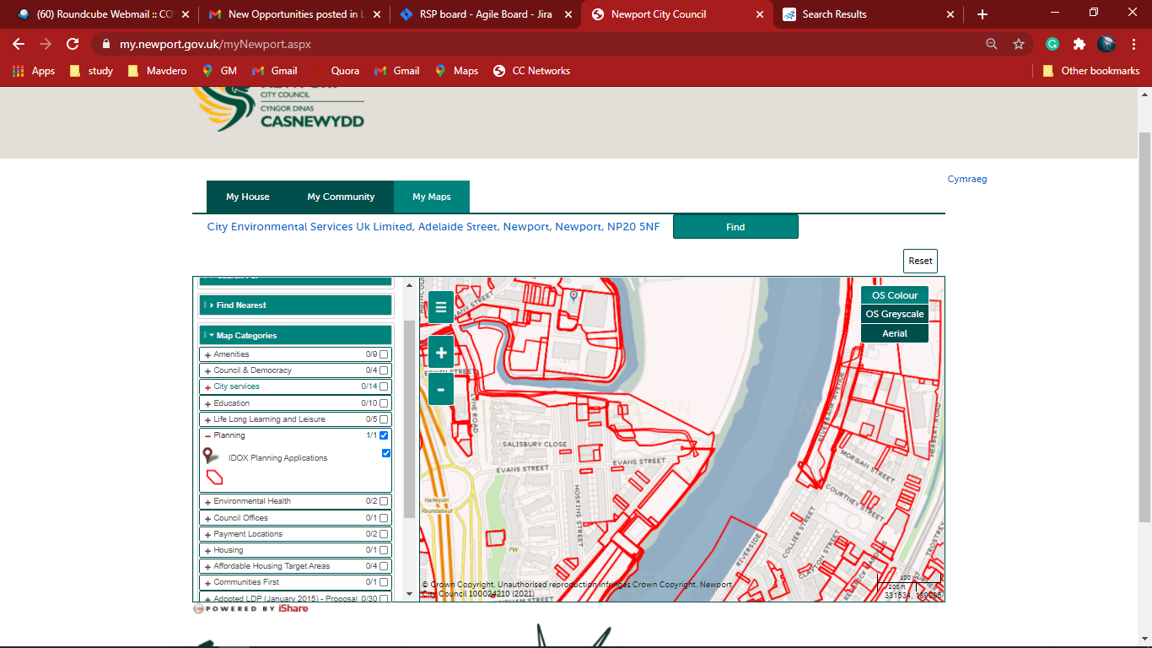

1. Bot will Click on dropped pin to reveal application details at that location

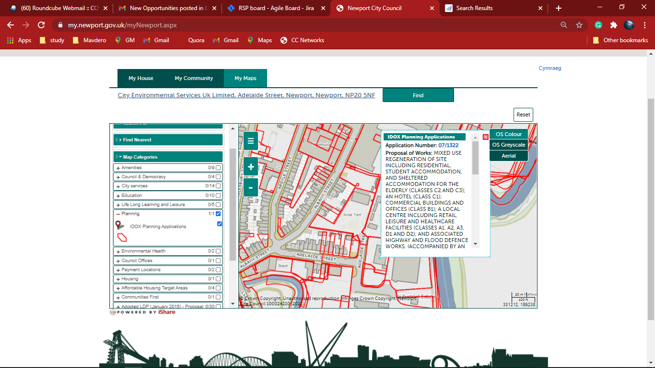

1. Bot will extract the planning summary in the excel sheet

